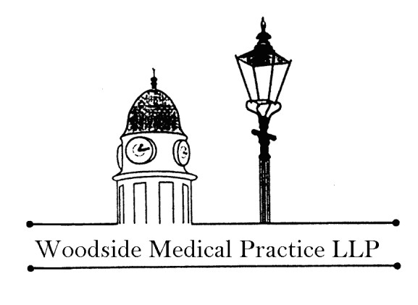

Woodside Fountain Health Centre
Great Northern Road, Aberdeen
AB24 2AS

Dr B L Finlayson
Dr K M Jack
Dr D Earley
Dr A Mishra
Dr H Anindo
Dr S Mir
Dr K Robertson
Dr S Cardno
Dr F Wahid
Dr A Ifezulike

Telephone 01224 492828

www.woodsidemedicalgroup.co.uk

Facebook page: Woodside Medical Group

The Doctors

Dr Brett L Finlayson MBChB FRCGP
Full-time Male GP

Dr Kerry M Jack MBChB FRCGP DRCOG
Part-time Female GP

Dr David Earley MBChB MRCGP
Full Time Male GP

Dr Scott Cardno MBChB MRCGP
Full Time Male GP

Dr Apurva Mishra MBBS MRCGP DPD
Part-time Male GP MScPD

Dr Hansa Anindo MBChB MRCP MRCGP
Part-time Female GP

Dr Shahid Mir MBBS MRCGP
Full-time Male GP

Dr Katherine Robertson BSc MBChB DFSRH MRCGP
Part-time Female GP

Dr Ferdous Wahid MBBS MRCGP
Part-time Male GP

Dr A Ifezulike MBBS MRCGP MBE
Part-time Female GP

We hold a General Medical Services (GMS) contract with NHS Grampian. Patients can obtain further information regarding primary care (GP) medical services in the area from Aberdeen City Health and Social Care Partnership, Primary Care Team, Marischal College, Broad Street, Aberdeen, AB10 1AB
The Practice Team

Practice Manager

Shona Alexander is our Practice Manager. She co-ordinates the day to day running of the practice and is assisted by Michelle Lorimer, Assistant Practice Manager and the team of administrative, secretarial and reception staff. Shona is your first line of contact should you have any queries or problems concerning the practice.

Receptionists & Administrative Team

Our highly professional team of receptionists are your first point of contact when you are dealing with the practice. They are there to ensure that you receive the best possible service from the practice but please remember that their job can be difficult and do try to be patient if they are busy and you are kept waiting. Our reception team is led by Angela, our Reception Supervisor

Our Administration team includes secretaries, senior administrator and administrators working behind the scenes to deal with correspondence received by the practice, including reports and results from all departments within NHS Grampian. Invitation letters are also sent by this department for the various clinics that are available at the practice. The team is also responsible for ensuring that our patients' records are kept up to date.

Advanced Nurse Practitioner

Our Advanced Nurse Practitioner, Julie, consults in the same way as our GPs and deals with a wide variety of issues. Our trained reception team will book your appointment with Julie when it is appropriate to do so, Julie can prescribe medication and complete referrals – referring to a GP when necessary to do that.

Practice Nurses

Our practice nurses offer a wide range of nursing services and operate an appointment system. The minimum appointment time is 10 minutes but this may be longer depending on the reason for your attendance. To make an appointment with the practice nurse please contact our reception staff who are happy to help you. It is extremely helpful if you can advise our receptionist of the reason for your visit to the practice nurse as this will allow them to make an appropriate appointment for you.

Our reception team are able to advise you of areas where the nurse can help you as it may not always be necessary to see the doctor.

Health Care Support Worker

Our Health Care Workers provide appointments to take blood samples, blood pressure readings etc should the doctor have ordered this to be done following a consultation. This service is also available at Community Treatment and Care Clinics located throughout Aberdeen – their services include blood pressure reading, blood tests, ear syringing, removal of stiches and sutures and wound care. The CTAC Clinics can be accessed by patients of the practice by calling the booking line on 01224 550200

District Nursing Team

We work very closely with our District Nursing teams who carry out nursing care for the patients at home. These visits are normally authorised by the GPs and, once you have been allocated to a team, you will receive contact details for them.

Health Visitors

We also work closely with our health visiting teams.

The Health Visiting teams offer health advice and support to new mums and families with young children. They see children for development checks and immunisation at the GP Surgery. In addition, they provide a Sleep Clinic, Continence Clinic and Parents Early Education Programme.

Once allocated to a Health Visitor, you will be provided with contact details for them.

Midwife

Our practice-attached community midwife is based at the Maternity Hospital (Telephone 552071). She is responsible for your antenatal care and has three antenatal clinics per week at the surgery. She will continue to care for you and your baby at home until the baby is about ten days old.

Drug Problem Service

Our practice-attached community drug problem service nurses are based at Cornhill Hospital and provide four sessions per week for the Practice.

Registration Process

When registering online, please provide photo identification e.g passport and/or drivers licence and proof of residency in this country, e.g. a utility bill. We would be grateful if you can provide records of immunisations, especially those for children, as your child may be immunised unnecessarily without this information also an accurate list of regular medicines (including dosages).

You need to complete a registration form for each person registering with the Practice. In addition, all patients will be asked to complete a new patient questionnaire, allowing us to provide medical care in the interim period, while your medical records are transferred from your old practice to this one.

We are able to offer interpreter services or language line at your appointments. Please let us know when you register if you will require these services.

Preference of Practitioner

Patients are registered with the practice, not with an individual GP, however, you can, at any time, express a preference for a practitioner you would like to deal with your issue. If your issue is urgent – this will be allocated to a clinician available that day. Not all the doctors in the practice provide all services and specific doctors may not be immediately available.

If you move out of the practice area, you will need to register with a new practice as soon as you move. We can provide information about how to find a new practice.

Surgery Opening Times

Monday to Friday 8.00am – 6.00pm
Saturday and Sunday Closed

Similar to other practices in Aberdeen, we participate in Protected Learning Time sessions that address the ongoing development of doctors, nurses and administrative staff. This means that we will be closed during these sessions. There are approximately six of these Protected Learning Time sessions per year. As with any closure of the Practice, an answering machine will give an emergency contact number.

To allow for staff meetings and training, the Practice may close over the lunchtime period. Advance notice of any closure is posted on the front door, in the reception area and in both waiting rooms.

Advice is available 24 hours per day from NHS 24 – telephone number 111

Appointments

Appointments are made by telephoning the practice receptionists who are available 8.00 am to 6.00 pm, Monday to Friday. The receptionist has been trained to allocate your request to the correct person at the correct time – initial appointments may be by telephone and, should the clinician assess that you need to be seen face to face, this will always happen.

Appointment slots are for 10 minutes. Separate appointments should be made if more than one family member requires to see a Doctor.

Urgent cases will be seen the same day, although it may not be with your usual doctor. Please explain to the receptionist if you need to be seen urgently.

If you cannot keep an appointment, please let us know as soon as possible. This allows your appointment to be given to another patient and so helps to improve our service to you.

Text Messages

We use text messaging to communicate with patients about appointment reminders, cancellation of clinics and changes in service provision. Please ask at reception or phone to opt out of this service.

On-line services

We offer On-Line Services which allow ordering of repeat medication and, as appropriate, the ability to book appointments. Patients are given user name and password and can use the service at their convenience. Patients need to complete a registration form which is available at reception or from our website, www.woodsidemedicalgroup.co.uk. Please note you will need to provide proof of ID in order to register for this service.

Services Available

All GP practices are contracted to provide “essential services”, that is, basic treatment of patients who are unwell. We also provide the following additional services:

- child health surveillance
- well baby clinic
- contraceptive services
- cervical cytology
- maternity medical services
- minor surgery services
- health checks (blood pressure & weight etc)

We also hold contracts with NHS Grampian for the following “enhanced services”:

- Regular monitoring, by blood and urine tests, for patients on a range of drugs for arthritis and bowel problems.
- A methadone substitution programme for patients with drug dependency problems.

The Practice holds Quality of Life clinics for review of patients with heart disease, stroke, asthma and COPD. We will invite you to make an appointment to have this review.

Home Visits

If you require a home visit then, wherever possible, please phone before 10.00am to allow the doctors to plan their day. The receptionist will take your initial details and you will be phoned back by the duty doctor as it may be that your problem can be dealt with by telephone advice, or that it would be more appropriate to send a nurse, or indeed arrange a hospital attendance. House visits are only available for patients who are housebound because of illness or disability.

Please remember that several patients can be seen in the practice in the time that it takes to make one home visit. There are also better facilities for examining and treating patients at the practice.

Ordering Repeat Medications

Some patients require regular medication and do not have to see the doctor each time they require a prescription.

Patients using the repeat prescribing system will be given a request slip listing the medications that can be ordered without seeing the doctor. Requests for repeats can be made in a number of different ways and will be picked up by your chosen pharmacy and available 4 working days after receiving your order.

Telephone number 01224 283977 is a dedicated line for patients to use when ordering repeat prescriptions. You will be asked to leave details of your name, date of birth, items required and a contact telephone number. It should be noted that messages left out of hours on this number will only be dealt with by practice staff during normal office hours.

Test Results

The Practice has a strict policy regarding confidentiality and data protection. We will only release test results to the person to whom they relate unless that person has given prior permission for the release of the results or they are not capable of understanding the results.

When phoning for test results, please phone between
10.00am and 12noon or between 2.00pm and 6.00pm.

Non-NHS Fees

Some services are not available under NHS General Medical Services, e.g. medical examinations for special purposes, provision of some certificates and some travel immunisations. These services will be charged to the patient directly.

Emergencies

IN SERIOUS EMERGENCIES DIAL 999 FOR AN AMBULANCE

During surgery opening hours telephone 01224 492828.

Please give as much information as possible to the receptionist who will then contact the duty doctor to arrange the best way to deal with your problem – this may be telephone advice, an urgent consultation or a home visit.

Out of Hours

IN SERIOUS EMERGENCIES DIAL 999 FOR AN AMBULANCE

In addition to providing 24 hour advice, NHS 24 along with GMED (Grampian Medical Emergency Department) provides emergency cover during the hours of 6pm and 8am when the practice is closed. If you need medical assistance between these hours, telephone NHS 24 on 111 (if you have any difficulties contacting NHS 24, please dial 100 for the operator).

A receptionist from NHS 24 will answer your call. They will either:
- Arrange for you to speak to a doctor or nurse
- Invite you to attend the centre to be seen by a doctor
- Arrange a home visit if you are too ill to visit the centre

Transport to and from the centre may be available if you cannot arrange this yourself. Out of hours cover is the responsibility of the local Health Board. Further advice and information can also be obtained from NHS 24, whom you can contact direct on 111 or by visiting www.nhs24.com.

Training

This practice is an approved General Practitioner training practice and we are privileged to have the services of a fully qualified doctor who is attached to the practice for a year in order to complete their training. As part of training we have to make video recordings of some consultations to help improve our skills. If any doctor wishes to video your consultations this will be discussed with you beforehand and your written consent will be obtained before and after any recording is done. You need not be videoed if you do not wish.

Teaching

Medical students and nursing students attend the practice from time to time. We hope that you will co-operate with us and help the students to learn about general practice. However, you will be informed of their presence in advance, and if you do not want them to be present at a consultation, your wishes will be respected. This will not affect your treatment in any way.

Locum Doctors

Occasionally we employ locum doctors when one of the doctors is unavoidably absent from the practice. Please be assured that these doctors are fully qualified and able to provide adequate cover for our patients.

Disabled Access

Access for disabled patients is via a ramp to the front door and all consulting rooms and treatment rooms are on the ground floor. We also have a specially designated disabled toilet. .

Carers and Housebound Patients

The Practice keeps a list of patients who are truly housebound and a record of patients who are carers. If you are a carer or you have a carer, please let us know. Similarly, if you are truly housebound please let us know along with any Day Centres you attend and the days you are there.

The Family Medicine Chest

It is quite useful to have a small supply of medicines in the house in case of emergencies. Here is a list of useful and inexpensive medicines that every household should have and a description of their use:-

Paracetamol
Useful for headaches, fever, minor sprains and bruises.

Calpol/Disprol
Useful for fever, earache and pain relief in young children.

Calamine Lotion
Useful for itchy rashes, chickenpox, sunburn and insect stings.

Menthol crystals
Add to hot water to make steam inhalations for catarrh and dry coughs.

Vapour rub
Rub on the chest for your children with snuffly noses or dry coughs.

REMEMBER TO KEEP ALL MEDICINES IN A LOCKED CUPBOARD OR STORE OUT OF REACH OF CHILDREN

Self Treatment of Minor Illnesses

Colds

Colds are very common in the winter months, especially in children who never seem to be free of them.

- Colds are caused by a virus infection and unfortunately there are no specific drugs to kill cold viruses. Treatment consists of controlling the symptoms until the body’s defences overcome the virus.

- A runny or blocked nose can be treated with steam inhalations and/or a decongestant, e.g. Sudafed, which can be bought from the pharmacy. Be careful of driving as some decongestants can make you slightly drowsy.

- Sore throats are helped by warm drinks containing honey or by sucking throat pastilles. Adults can gargle with a solution of soluble Aspirin every four hours. Most people find sore throats will take 2-3 days to improve.

- Coughs are helped by steam inhalations, especially at bedtime as this helps irritating coughs and loosens catarrh. Steam is also good for croupy coughs in young children. Cough mixtures are expensive and may not make much difference. Care must be taken when using hot water, especially with children. Pharmacists are happy to advise on medication for self-limiting illnesses.

Influenza

“Flu” is commonly seen in the winter months and presents with the following symptoms:- fever, shivers, muscular aches and pains, headache, runny nose, sore throat and sometimes vomiting. The best treatment for flu is bedrest, regular Paracetamol or Ibuprofen and plenty of fluids. The same advice applies to children. The symptoms can last up to one week. If symptoms are very severe or prolonged you should consult the doctor. Antibiotics do not cure colds or flu.

Gastroenteritis

Most gastroenteritis is caused by a virus and is self-limiting. Symptoms are diarrhoea and vomiting with abdominal cramps plus fever and generalized aches and pains. Treatment in most cases consists of bedrest, resting the stomach by taking clear fluids only and paracetamol for fever and aches. If symptoms are prolonged or severe the doctor should be consulted.

Toothache

Toothache may be helped by trying simple analgesia, e.g. paracetamol but if symptoms do not settle consult your Dentist. Dentists are now available for emergency treatment 24 hours a day if you are a registered dental patient. Dental helpline 0845 456 5990.

Nose Bleeds

Small nose bleeds are not uncommon, especially in children. Nose bleeds are treated by leaning forward and pinching the lower soft part of the nose firmly for 10 to 15 minutes. Nose bleeds can be more severe in the elderly and if the bleeding does not stop after pressure contact the Doctor.

Chickenpox

The rash of chickenpox starts with small red patches and small blisters develop within three to four hours. During the next three to four days these will crust over and fall off although new crops of blisters may occur. The rash is usually itchy and application of Calamine Lotion soothes the skin. Cool baths may also help. Chickenpox is caused by a virus and is self-limiting. Children may return to school once the rash scabs over. Remember to notify us if you or a member of your family contracts Chickenpox.

Sunburn

Wash sunburn with cold water to remove the heat. Calamine lotion will relieve irritation and paracetamol will relieve pain. Remember that children tend to burn easily even in the Aberdeen sun, so apply sunblocks early. Prevention is better than cure.

Bites and Stings

Anti-histamine tablets, which can be purchased at your local pharmacy without prescription, usually relieve most symptoms of bites and stings.

Pharmacy First Information

You can receive advice and treatment for a wide range of minor illnesses from your local pharmacy, our reception team will direct you to this service when appropriate to do that.

Confidentiality

How we use your medical records

- This practice handles medical records in line with laws on data protection and confidentiality.

- We share medical records with those who are involved in providing you with care and treatment.

- We may also share medical records for medical research and to check the quality of care provided to you.

- We share information when the law requires us to do.

- For more information ask at reception for a leaflet or visit our website: http://www.woodsidemedicalgroup.co.uk/

Information Sharing

The practice complies with current Data Protection and Access to Medical Records legislation. Identifiable information about you will be shared with others in the following circumstances:

- To provide further medical treatment for you, e.g. from district nurses, hospital services and out of hours services
- To help you get other services e.g. from social work department. This requires your consent.
- When we have a duty to others e.g. in child protection cases

Anonymized patient information will also be used at local and national level to help the Health Board and Government plan services e.g. for diabetic care. If you do not wish anonymous information about you to be used in such a way, please let us know

Patients Rights and Responsibilities

You will be treated with respect and as a partner in your care. Being a partner means you have responsibilities too.

We will:
- Ensure our patients have 24-hour access to medical advice
- Provide access to a suitably qualified medical professional, in cases where urgent case is required, this will be provided on the same day
- Work in partnership with you to achieve the best medical care possible
- Involve you and listen to your opinions and views in all aspects of your medical care
- Advise and inform you of the steps you can take to promote good health and a healthy lifestyle to aid in the prevention of disease, illness and injury.

We would respectfully ask that you:
- Let us know if you intend to cancel an appointment or are running late
- Treat staff with courtesy and respect. Reception staff may have to ask some personal questions to assist us in providing you with the best service
- Inform the practice staff of any alterations in your circumstances, such as change of surname, address or telephone number. Please ensure that we have your correct telephone number, even if it is ex-directory

As patients you are responsible for your own health and that of any dependents. It is important that you adhere to information and advice given to you by health professionals, and co-operate with the practice in endeavouring to keep you healthy.

If you are removed from the practice list due to failing to attend for your appointments, you will not be permitted to re-register until 3 years after the date you were removed.
Complaints

We make every effort to give the best service possible to everyone who attends our practice. However, we are aware that things can go wrong resulting in a patient feeling that they have a genuine cause for complaint. If this is so, we would wish for the matter to be settled as quickly, and as amicably, as possible.

Complaints should be directed to Shona Alexander, Practice Manager and in her absence, Michelle Lorimer, Assistant Practice Manager. Complaints can be made in person, by phone, by e-mail or in writing, and will be dealt with in strictest confidence. If a complainant acts on behalf of someone else, written authorisation from that person will require to be made available to us. We encourage patients to discuss their concerns with us, so that we may improve upon the existing service we provide.

When investigating a complaint we aim to find out happened to result in a complaint and identify what we can do to make sure the problem does not happen again.

In instances where the practice has been unable to resolve complaints satisfactorily, patients should write to:

Scottish Public Services Ombudsman
4 Melville Street
Edinburgh
EH3 7NS
Tel 0800 377 7300

Quick guide to the NHSG complaints procedure

Complaints procedure

You can make your complaint in person, by phone, by e-mail or in writing.

We have a two-stage complaints procedure. We will always try to deal with your complaint quickly. But if it is clear that the matter will need a detailed investigation, we will tell you and keep you updated on our progress.
Stage one: early, local resolution

We will always try to resolve your complaint quickly, within five working days if we can.

If you are dissatisfied with our response, you can ask us to consider your complaint at Stage two.
Stage two: investigation

We will look at your complaint at this stage if you are dissatisfied with our response at Stage one. We also look at some complaints immediately at this stage, if it is clear that they are complex or need detailed investigation.

We will acknowledge your complaint within three working days. We will give you our decision as soon as possible. This will be after no more than 20 working days unless there is clearly a good reason for needing more time.
The Scottish Public Services Ombudsman

If, after receiving our final decision on your complaint, you remain dissatisfied with our decision or the way we have handled your complaint, you can ask the SPSO to consider it.

Violence Statement

Zero Tolerance Policy

The practice considers aggressive behaviour to be any personal, abusive and/or aggressive comments, cursing and/or swearing, physical contact and/or aggressive gestures.

The practice will request the removal of any patient from the practice list who is aggressive or abusive towards a doctor, member of staff, other patient, or who damages property.

All instances of actual physical abuse on any doctor or member of staff by a patient or their relatives will be reported to the police as an assault.

Sources of Information

The Practice does not produce its own leaflets; however, leaflets and written information about various illnesses and conditions are available on display and from the practice nurses.

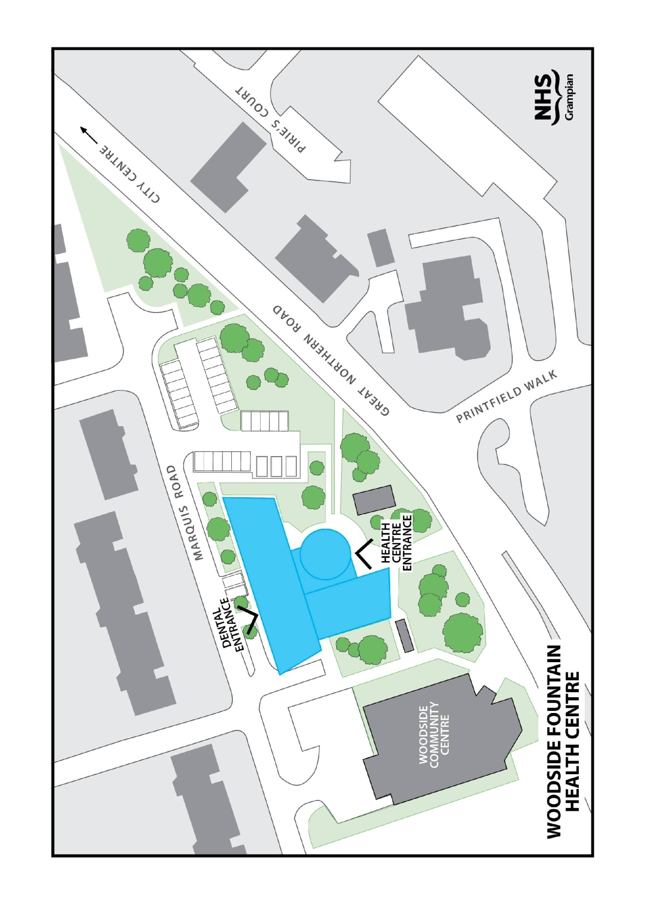
PRACTICE LOCATION

Car Park
Woodside Fountain Health Centre has a car park available for the use of patients who are attending the practice. The entrance to the car park is off Marquis Road. The post code for sat nav is AB24 2QY.

Public Transport
The main bus routes closest to the practice are operated by First Bus and there are various stops on Great Northern Road. The bus route numbers are the 17, and 727.

Practice Boundary

Woodside Medical Practice provides general medical services for patients residing primarily in the north part of the city, around Hilton and Tillydrone. We do not accept patients who live in Cults, Kingswells, Dyce, Bridge of Don or other areas outwith our boundary. Our boundary is under continual review and may be subject to change. Please contact the surgery should you require any clarification of specific details.

Patients of the Practice who move outwith the practice boundary must register with a General Practitioner within their area.

Other Formats

Should you require this leaflet in any other language or format, please contact the surgery as we may be able to organise this for you.

Publication date – August 2022

